Gilching, February 23rd, 2024
Lopec preview
Functional adhesives and UV curing systems for flexible electronics

Flexible electronics manufacturers are pushing traditional boundaries such as volumetric form factor, functionality, and design flexibility in consumer electronics. To this end, Panacol and Hönle UV Technology have successfully developed turnkey solutions comprising of multi-functional adhesives and UV curing equipment, that can be tailored for novel Photovoltaic and flexible electronics applications.

For OPV applications, these new UV and UV-LED curable adhesives were developed specially for laminating barrier foils. They provide higher resistance to environmental stresses, an improved compatibility to the PV material and low WVTR (Water Vapor Transmission Rate). Being UV-curable, these adhesives offer high throughput processes, including roll-to-roll that can be run with greater efficiency reducing total cost of ownership. The adhesives requirements such as flow properties can be modified in this context to suit the application process perfectly.

Flexible and bendable uv adhesives have also been created for more traditional applications that are now being performed on flex circuits. They include new underfills for die-attach as well as structural adhesives for component edge bonding. All uv adhesives from Panacol get easily cured with high intensity UV and/or UV-LED curing systems from Hönle, which perfectly match the wavelengths of the Panacol photoinitiators. Their light footprint options range from 3 mm diameter spot units to linear LED arrays that can exceed one meter in length, making it the perfect choice for smaller and larger irradiation areas.

The latest conductive adhesives from Panacol can efficiently secure flexible resistors and create flexible electrical connections in solar cells, touch sensors and wearable devices. This includes a one-component, silver-filled conductive adhesive that adheres very well to plastics, including polyimide, PC, PVC, ABS, and FR4 boards. When fully cured, the adhesive is very flexible with high peel strength, making it the perfect choice for use in applications subject to vibration, oscillation or rapid temperature changes. A major advantage is its very easy handling and storage as it only needs to be stored refrigerated, not frozen. It is easily dispensed, and cures within minutes at temperatures as low as 100°C. This makes it possible to fixture semiconductors and create electrical connections in a single step.

The specific requirements of the application and its assembly process are key factors to consider when making an adhesive selection. Significant benefits can be realized when component design assembly, adhesive properties, and the curing process (UV or thermal) are precisely coordinated. Panacol works closely with manufacturers in all facets to assist in creating an optimized bonding process. This results in increased efficiency and reduces total operational costs.

Visit us at Lopec, the International Exhibition for Flexible, Organic and Printed Electronics in Munich/Germany. From 6th to 7th March 2024, you find us in Hall B0, Booth 614 and get more information about our latest developments.

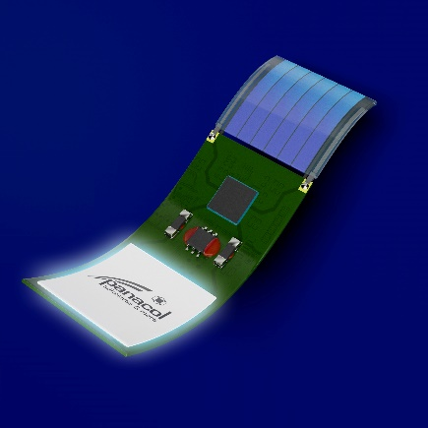
Caption:
Flexible adhesives are used for foil lamination, electrical conductive bonding, underfills, edge bonds and SMD fixation on a flexible PCB and OPV cell
Photo: Panacol
Note: The photographic material may only be published in connection with the associated press release.

About Hönle: The Dr. Hönle AG is a leading provider of industrial UV technology based in Gilching. With more than 600 employees, the Hönle Group develops innovative solutions for different areas of application.

One focus of the business activity is the development and sale of industrial adhesives and casting compounds. Devices for drying paint and varnish, curing adhesives and plastics, as well as for sterilizing air, water and surfaces and simulating sunlight are also manufactured. In addition, the group of companies produces UV lamps and products made of quartz glass, among other things for sterilization and drying processes.

The Hönle Group supplies technology and world market leaders worldwide and is represented in over 20 countries with its own companies and partner companies.

Hönle is ISO 9001 and ISO 14001 certified. All Hönle products bear the CE mark.

