Peel-resistant and watertight

The Allrounder for Seal-Bonding
Windach, 20 June 2017 | DELO Industrial Adhesives has developed a light-curing acrylate with excellent peel resistance for seal-bonding. DELO PHOTOBOND GB4033 has features that make it suitable for universal use, for example, in electronic applications.
Designed for service temperatures ranging from -40 °C to +120 °C, it is particularly suited for material joints that require adhesives not only to be strong but also flexible and tight. The product provides very good sealing properties against water, humidity, and dust, as is often required in the world of consumer electronics.
In addition, an elongation at tear of 400 % allows it to equalize tensions to a large extent. This elasticity contributes to the good peel resistance on glass and plastic. Its average peel strength on PEEK, PC, or PET is 14 N/cm compared to 1-3 N/cm for standard acrylates.
DELO PHOTOBOND GB4033 is fluorescent in blue, which is very useful for controlling precise application of the adhesive and for process control. The adhesive cures under both UV and visible light. This large wavelength coverage makes it possible to use transparent materials with low transmittance such as PC. The minimum curing time to reach final strength is four seconds at typical intensities of 200 mW/cm², enabling high-volume applications at short cycle times.
The low-viscous, one-component adhesive is solvent-free and can be stored at room temperature.
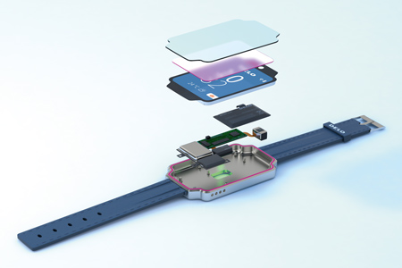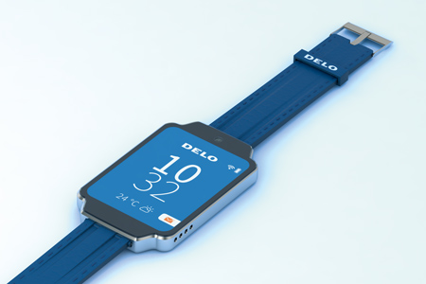
Designed for electronic applications such as wearables: The new all-rounder for seal-bonding (Figure: DELO)

About DELO Industrial Adhesives  DELO is a leading manufacturer of industrial adhesives with its headquarters in Windach near Munich, Germany, and subsidiaries in the USA, China and Singapore. In fiscal year 2017, 560 employees generated sales revenues of EUR 95 million. The company supplies customized special adhesives and associated technology for high-tech industries such as automotive, aviation, optoelectronics, and electronics. Its customers include Bosch, Daimler, Infineon, Osram and Siemens. DELO won the Hidden Champion Award of the German news broadcaster n-tv in 2016. | Press contact  Matthias Stollberg  DELO Industrial Adhesives  DELO-Allee 1  86949 Windach – Germany  Phone: +49 8193 9900-212  E-mail: matthias.stollberg@delo.de  www.DELO.de

