New two-component potting compound for automotive electronics

Reliable Protection of Sensors
Windach, November 28, 2017 | DELO Industrial Adhesives has expanded its product range by a new potting compound for automotive and power electronics. DELO-DUOPOX CR8031 protects electronic components such as sensors even at high temperatures and is easy to handle.
The two-component epoxy resin shows good adhesion to various plastics such as PA or ABS. Even with PE, a compression shear strength of 20 MPa was reached after plasma pretreatment, although this cheap and resistant plastics is difficult to bond due to its low surface energy.
With an elongation at tear of 5 %, DELO-DUOPOX CR8031 is tough-hard and withstands permanent temperatures of up to 180 °C. Even after 1000 hours of storage at maximum temperature of use, or at 85 °C and 85 % air humidity, the product's mechanical properties remain unchanged. Furthermore, it is resistant to oil and fuel, a property that makes it suitable for applications in the engine compartment – for example for potting of sensors and printed circuit boards or for sealing of housings.
The epoxy resin achieves this reliability without any fillers, thus providing many benefits in terms of processing. Since there is no risk of filler sedimentation, no stirring of the potting compound is required and, consequently, no degassing either, which results in a simpler system design. Additionally, this low-viscous product exhibits very good flow behavior.
DELO-DUOPOX CR8031 is mixed in a 2:1 ratio. Not only can it be used for fully automatic production, but it is also well suited for semi-automatic processes in medium production volumes. Dispensing guns with their static mixing tubes allow the resin to be applied virtually like a one-component adhesive. The epoxy resin has been optimized for fast production and can be heat-cured within 10 minutes at 80 °C. Without additional heating, it reaches its functional strength after 16 hours of curing at room temperature, thus saving energy and minimizing stress on the component.
The product is black and can be stored at room temperature.
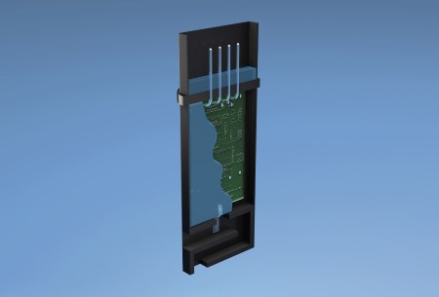
Also suitable for applications in the motor compartment: the new DELO-DUOPOX CR8031 potting compound (Figure: DELO)

About DELO Industrial Adhesives  DELO is a leading manufacturer of industrial adhesives with its headquarters in Windach near Munich, Germany, and subsidiaries in the USA, China and Singapore. In fiscal year 2017, 560 employees generated sales revenues of EUR 95 million. The company supplies customized special adhesives and associated technology for high-tech industries such as automotive, aviation, optoelectronics, and electronics. Its customers include Bosch, Daimler, Infineon, Osram and Siemens. DELO won the Hidden Champion Award of the German news broadcaster n-tv in 2016. | Press contact  Matthias Stollberg | Katharina Trettin  DELO Industrial Adhesives  DELO-Allee 1  86949 Windach – Germany  Phone: +49 8193 9900-212 | -391  E-mail: matthias.stollberg@delo.de | katharina.trettin@delo.dewww.DELO.de  www.delo-adhesives.com/en

