DELO extends its product range

New Adhesives for Reliable Bonding of Displays
Windach, January 18, 2018 | DELO extends its product range with two adhesives that are particularly suitable for reliably fixing display frames – a one-component, light-activated urethane polymer and a two-component polyurethane hybrid.
Displays are omnipresent – whether in smartphones, in vehicles, or as touchscreens of control units. However, different adhesives can be used for bonding display frames, cover glass, or for joining display panel and housing.
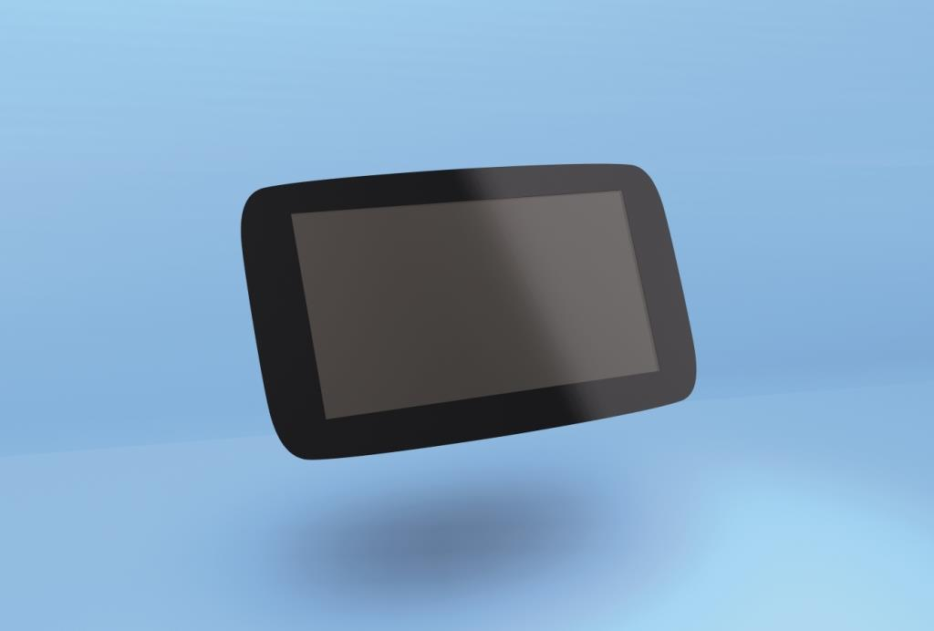

Displays are omnipresent. There are different adhesives for the reliable
fixing of display frames. (Figure: DELO)
Guarantees Fast Production: DELO PHOTOBOND LA4860
DELO PHOTOBOND LA4860 is a modified urethane polymer. The special feature of the one-component adhesive is its curing mechanism which is based on light activation with subsequent humidity curing. The curing starts as soon as the adhesive is exposed to UV light or visible light, directly after dispensing and before joining the components. The actual curing takes place at room temperature after joining, through the influence of the ambient air's humidity. Initial strength is reached after a few minutes already. Achieving a pre-fixation in seconds accelerates production processes and is also of advantage if the adhesive is to be used for sealing, coating, potting, or encapsulating.
Thanks to the novel curing mechanism, opaque components such as display frames, which often have a black mask on the edge areas or are bonded to the housings, can be quickly and reliably joined without the need for additional heat curing.
The solvent-free adhesive can be used at temperatures ranging from -40 °C to +110 °C and has very good tension-equalizing characteristics thanks to an elongation at tear of 350 %.
Optimal Solution for Sealing Large Bonding Gaps: DELO-PUR SJ9356
Another product used for bonding display frames and housings is DELO-PUR SJ9356, a polyurethane-based adhesive, free of isocyanates and silicones.
The two-component adhesive cures at room temperature and reaches its initial strength after approximately 4 hours. Its flexibility ensures stable and tension-equalizing bonds and seals, even with dynamic loads. The adhesive's flow resistance and excellent wet adhesion makes it well suited for sealing larger gaps (> 2 mm), thus protecting components permanently against humidity and dust.
To simplify its handling, DELO-PUR SJ9356 is not only available in hobbocks, but also in double chamber cartridges. Mixing and dispensing the two-component polyurethane adhesive is thus easy and fast.
DELO-PUR SJ9356 features a temperature range from -40 °C to +105 °C and an elongation at tear of 120 %.

About DELO Industrial Adhesives  DELO is a leading manufacturer of industrial adhesives with its headquarters in Windach near Munich, Germany, and subsidiaries in the USA, China and Singapore. In fiscal year 2017, 560 employees generated sales revenues of EUR 95 million. The company supplies customized special adhesives and associated technology for high-tech industries such as automotive, aviation, optoelectronics, and electronics. Its customers include Bosch, Daimler, Infineon, Osram and Siemens. DELO won the Hidden Champion Award of the German news broadcaster n-tv in 2016. | Press contact  Matthias Stollberg | Katharina Trettin  DELO Industrial Adhesives  DELO-Allee 1  86949 Windach – Germany  Phone: +49 8193 9900-212 | -391  E-mail: matthias.stollberg@delo.de | katharina.trettin@delo.dewww.DELO.de  www.delo-adhesives.com/en

